**Database Project Step 4 Report: Web Interface**

1. **Introduction**

In this phase of the project, we will design a user-friendly web interface to effectively use the database we created in phase 3. In this way, the changes we make in our interface are instantly reflected in our company database thanks to 20 procedures and these are displayed instantly with the help of tables in the web interface. In addition, from the views tab, you can access the total, average, maximum and minimum values ​​of data such as company, employees, items, service status. Finally, you can easily reach the table, procedure or view you want to reach with the search bar.

1. **Web Interface**

When you first access the user interface it looks as follows. You can access current company database tables and information from the tables and views section on the left..

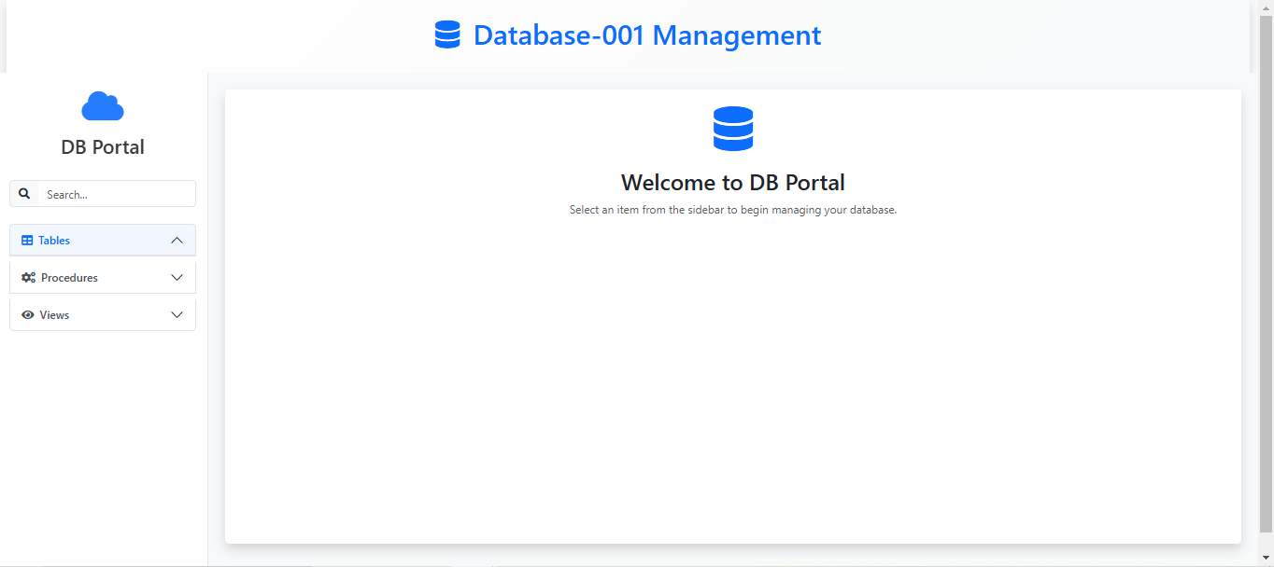

The procedures section contains procedures designed to perform a specific task or process for the company. These procedures are divided into 4 as Create/Insert, Read/Get, Update and Delete.

* 1. **Create/Insert Procedures**

These procedures are used when creating or adding something to the company database.

* + 1. **InsertCompany**

In InsertCompany procedure, we ask the company for 7 parameters(Companyid, Companyname, Tradenumber, Street, City, State, Country) and add a new company to the company database. The web interface image is as follows;

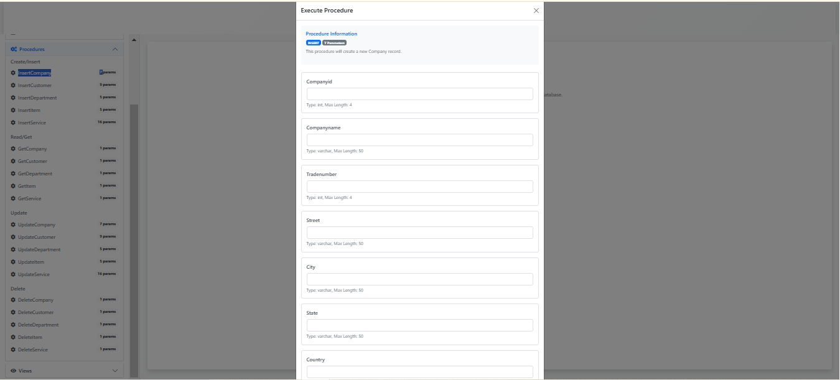

Without any additional company entries, the company table of the company appears in the figures below;

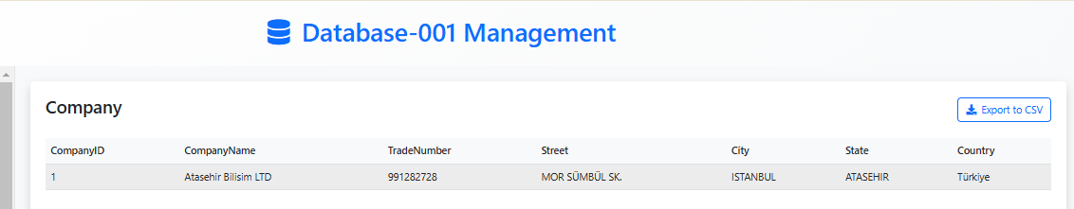

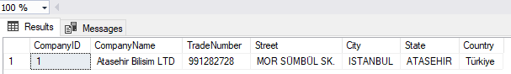

If a new company is added with the information Companyid=2, Companyname=A, Tradenumber=12, Street=B, City=C, State=D, Country=E, the new display in the database will be as follows;

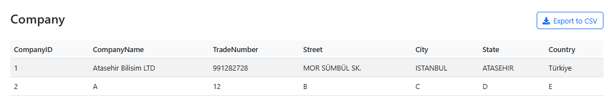

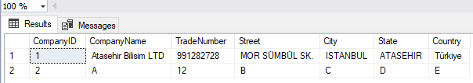

* + 1. **InsertCustomer**

In InsertCustomer procedure, we ask the customer for 9 parameters(Customerid, Customername, Email, Telephoneno, Street, City, State, Country, Companyid) and add a new customer to the company database. The web interface image is as follows;

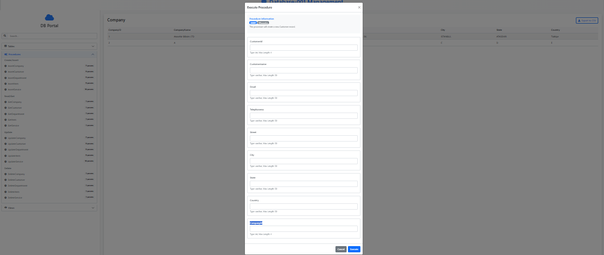

Before any customer registers to the system, the database looks like this:

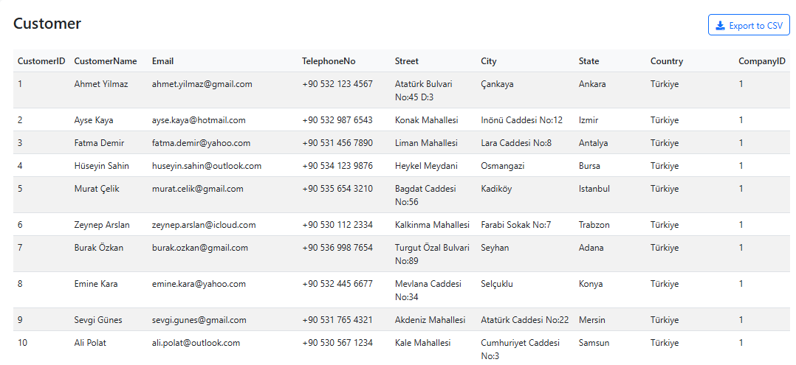

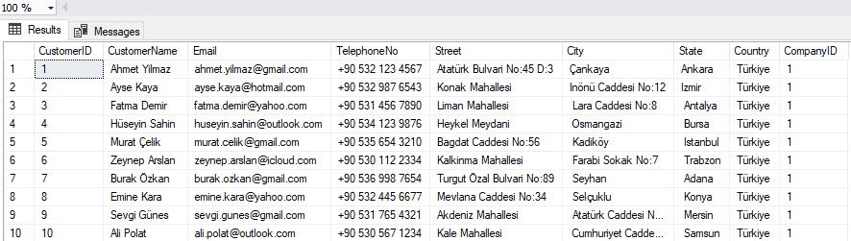

If a new customer is register with the information Customerid=0, Customername=A, Email=B, Telephoneno=C, Street=D, City=E, State=F, Country=G, Companyid=1, the new display in the database will be as follows;

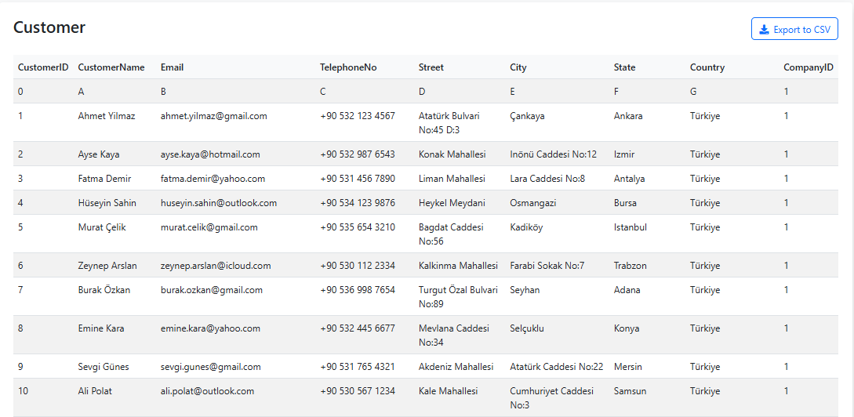

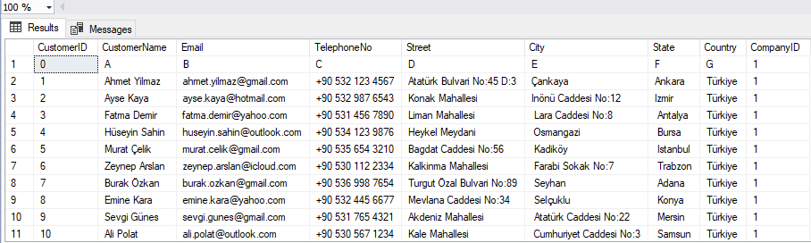

* + 1. **InsertDepartment**

In InsertDepartment procedure, we ask the department for 5 parameters(Departmentno, Departmentname, Noofemployees, Mission, Companyid) and add a new department to the company database. The web interface image is as follows;

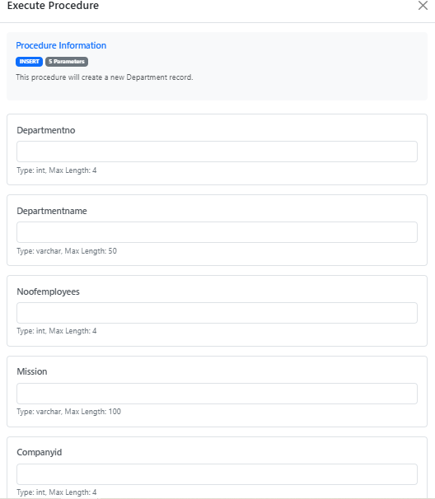

Before any other departments registers to the system, the database looks like this:

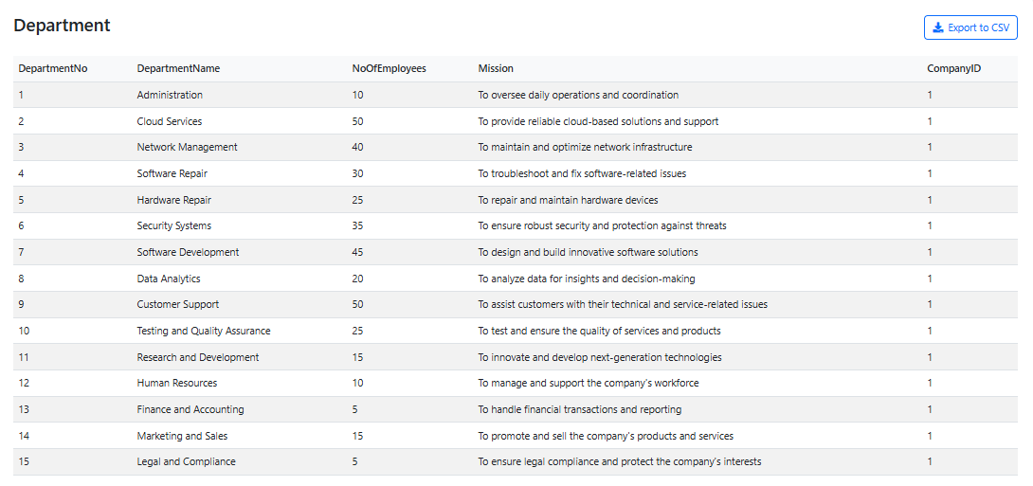

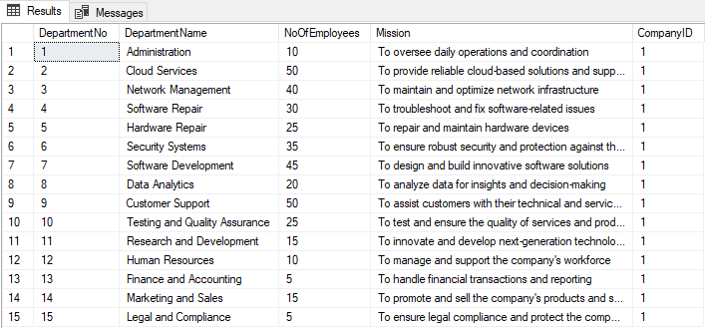

If a new department is register with the Departmentno=0, Departmentname=A, Noofemployees=5, Mission=B, Companyid=1, the new display in the database will be as follows;

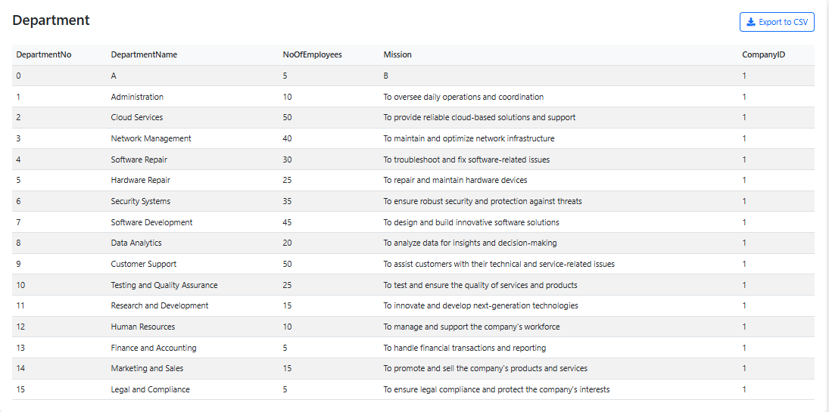

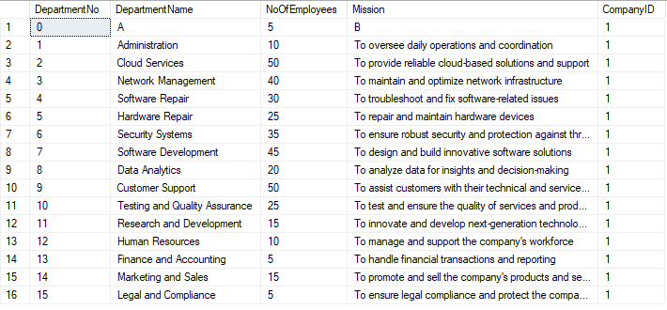

* + 1. **InsertItem**

In InsertItem procedure, we want the 5 parameters from item(Itemid, Itemname, Quantity, Price Companyid) and add a new item to the company database. The web interface image is as follows;

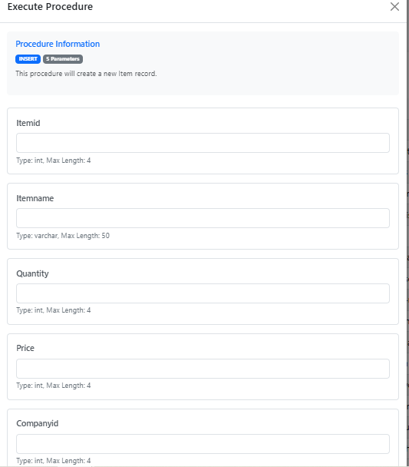

Without any additional item entries, the items table of the company appears in the figures below;

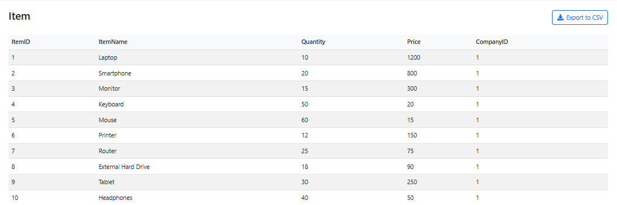

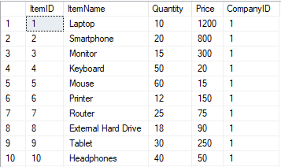

If a new item is register with the information with Itemid=0, Itemname=A, Quantity=5, Price=10 and Companyid=1, the new display in the database will be as follows;

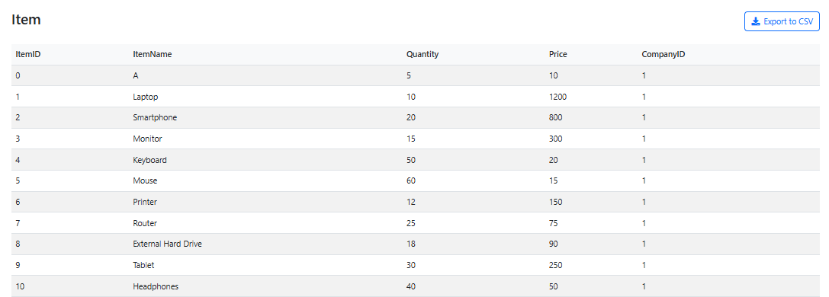

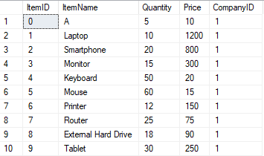

* + 1. **InsertService**

In InsertService procedure, we want the service for 16 parameters(Serviceid, Name, Startdate, Enddate, Price, Status, City, State, Country, Cloud, Security, Repair, Network, Softwaredev, Companyid, Departmentno) and add a new service to the company database. The web interface image is as follows;

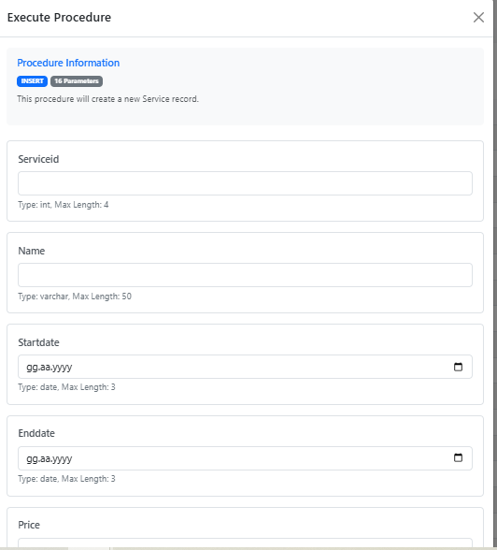

Without any additional services entries, the services table of the company appears in the figures below;

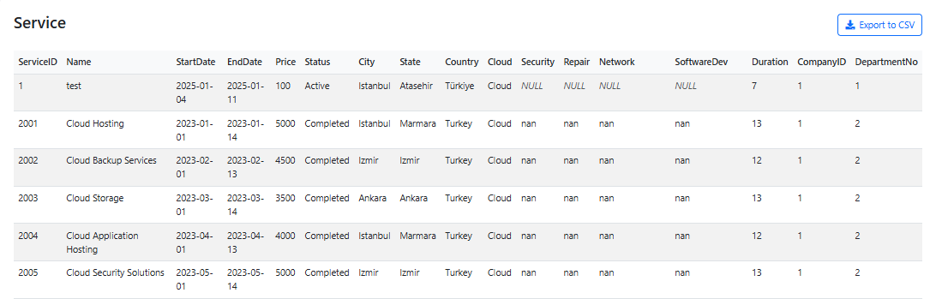

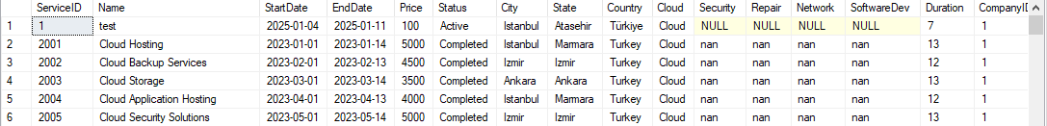

If a new services is register with the information Serviceid=0, Name=A, Startdate=13.12.2002, Enddate=05.05.2004, Price=2, Status=B, City=C, State=D, Country=E, Cloud=NULL, Security=NULL, Repair=NULL, Network=NULL, Softwaredev=F, Companyid=1, Departmentno=1, the new display in the database will be as follows;

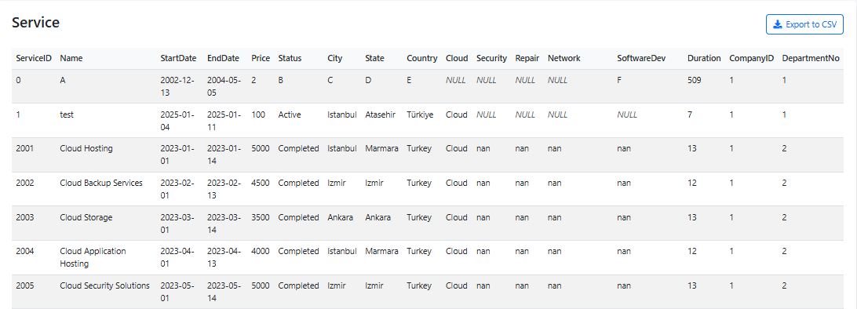

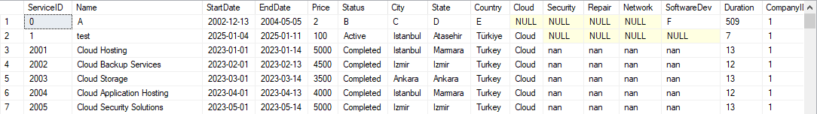

* 1. **Read/Get Procedures**

A stored procedure that performs a specific task on a database and is usually read-only.

* + 1. **GetCompany**

In GetCompany procedure, we ask the company just for 1 parameters(Companyid) and show the company. The web interface image is as follows;

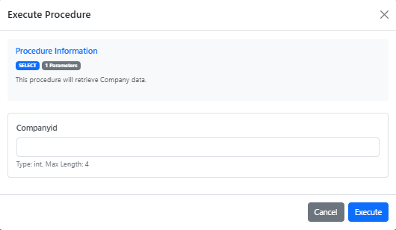

If a company with CompanyID number 1 is displayed, we get the following image;

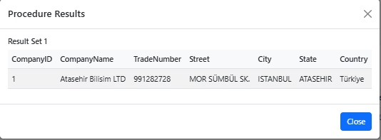



* + 1. **GetCustomer**

In GetCostomer procedure, we ask the customer just for 1 parameters(Customerid) and show the company. The web interface image is as follows;

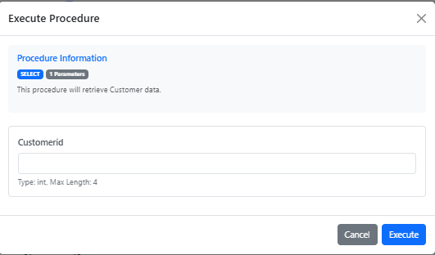

If a customer with CustomerID number 1 is displayed, we get the following image;

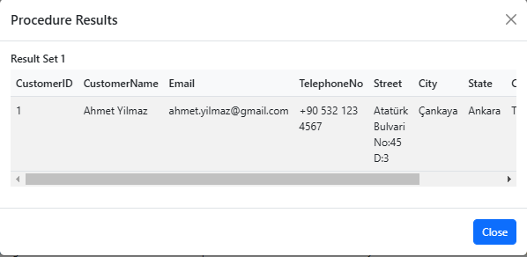



* + 1. **GetDepartment**

In GetDepartment procedure, we ask the department just for 1 parameters(Departmentid) and show thedepartment. The web interface image is as follows;

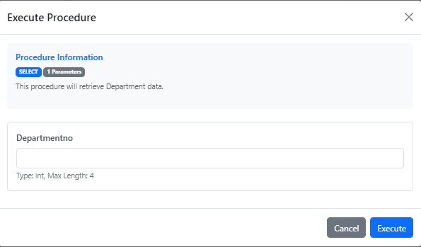

If a department with DepartmentID number 1 is displayed, we get the following image;

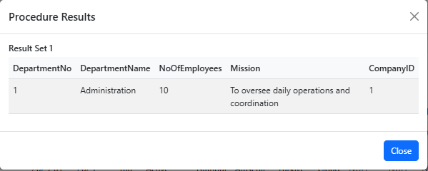



* + 1. **GetItem**

In GetItem procedure, we want the item just for 1 parameters(Itemid) and show the ıtem. The web interface image is as follows;

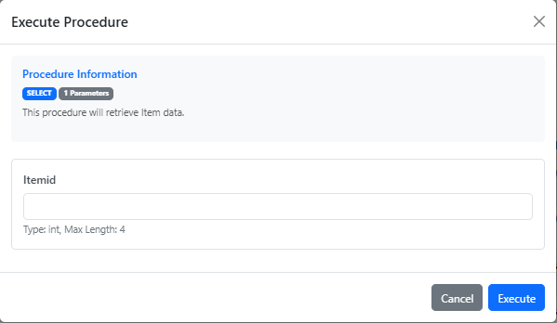

If a item with ItemID number 1 is displayed, we get the following image;

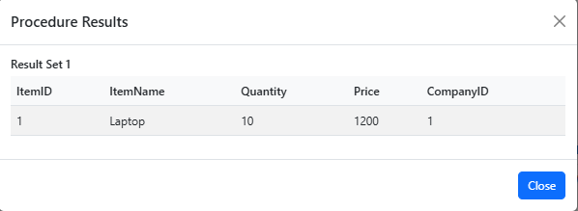



* + 1. **GetService**

In GetService procedure, we want the item just for 1 parameters(Serviceid) and show the service. The web interface image is as follows;

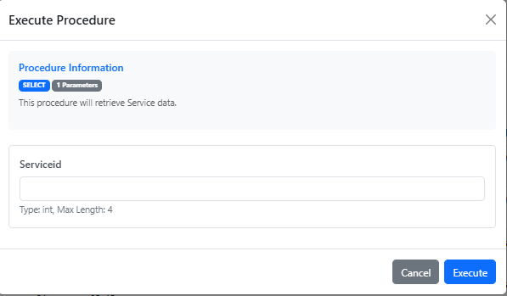

If a service with ServiceID number 1 is displayed, we get the following image;

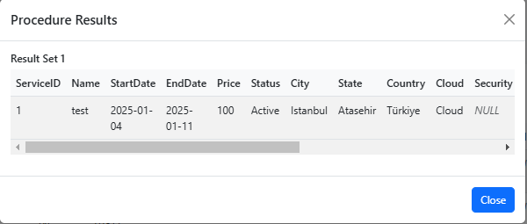



* 1. **Update Procedures**

Creates update procedures for incorrect or incomplete data entered in the update procedure

* + 1. **UpdateCompany**

In UpdateCompany, we ask the company for 7 parameters(Companyid, Companyname, Tradenumber, Street, City, State, Country) and update information a company to the company database. The web interface image is as follows;

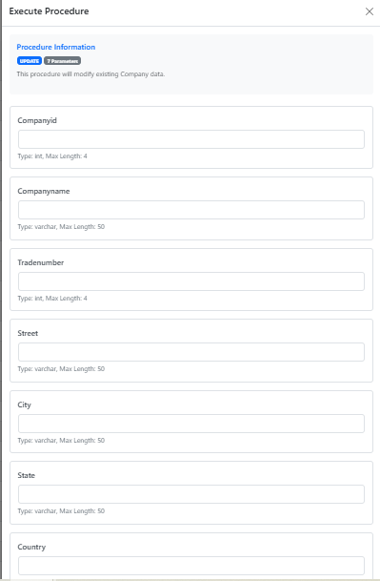

Without any additional company uptades, the company table of the company appears in the figures below;

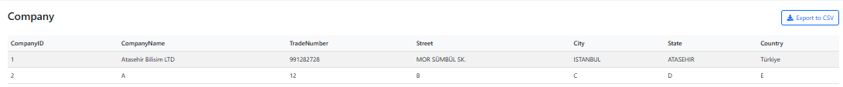



If we update the company name of the company with CompanyID number 2 to AAAA, the new display in the database will be as follows;

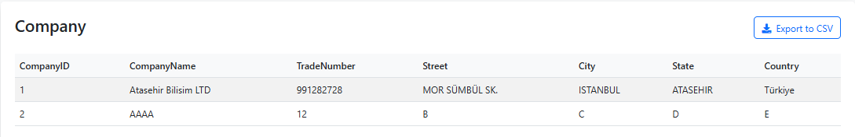

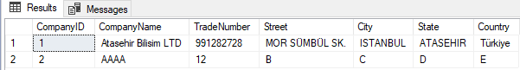

* + 1. **UpdateCustomer**

In UpdateCustomer procedure, we ask the customer for 9 parameters(Customerid, Customername, Email, Telephoneno, Street, City, State, Country, Companyid) and update information a customer to the company database.. The web interface image is as follows;

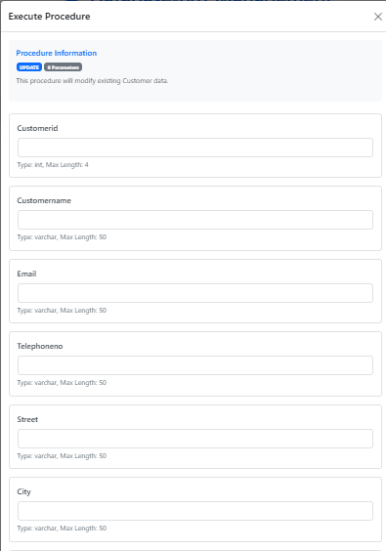

Without any additional customer uptades, the customer table of the company appears in the figures below;

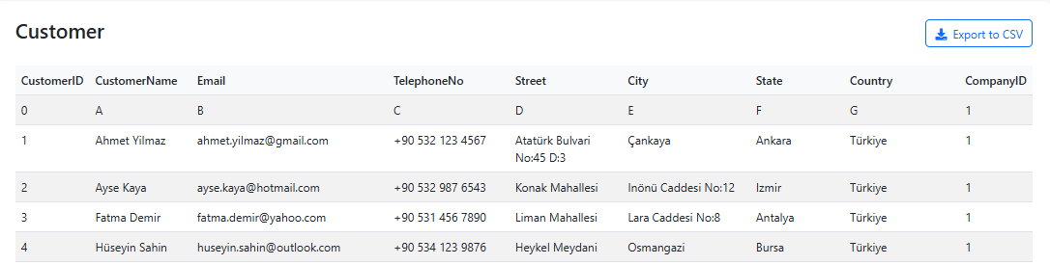

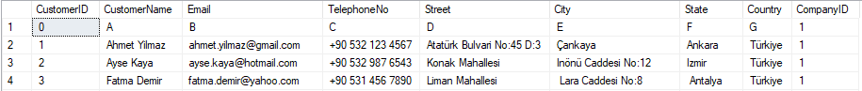

If we update the customer city of the customer with CompanyID number 1 to AAAA, the new display in the database will be as follows;

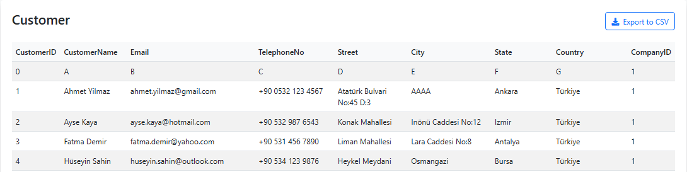

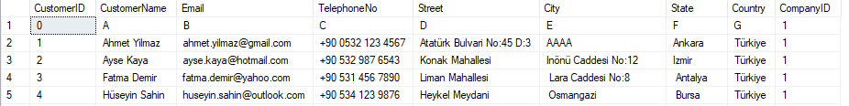

* + 1. **UpdateDepartment**

In UpdateDepartment procedure, we ask the customer 5 parameters(Departmentno, Departmentname, Noofemployees, Mission, Companyid) and update information a department to the company database.. The web interface image is as follows;

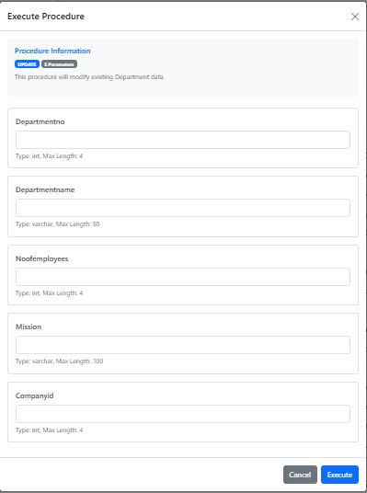

Without any additional department uptades, the department table of the company appears in the figures below;

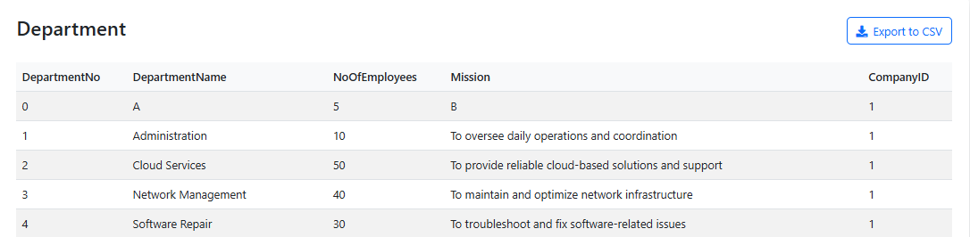

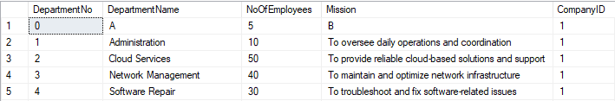

If we update the DepartmentName of the customer with DepartmentID number 0 to AAAA, the new display in the database will be as follows;

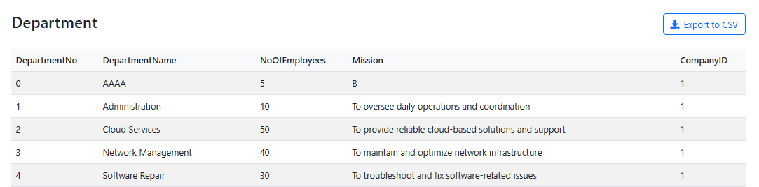

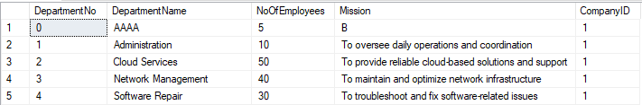

* + 1. **UpdateItem**

In UpdateItem procedure, we ask the customer 5 parameters from item(Itemid, Itemname, Quantity, Price Companyid) and update information a item to the company database.. The web interface image is as follows;

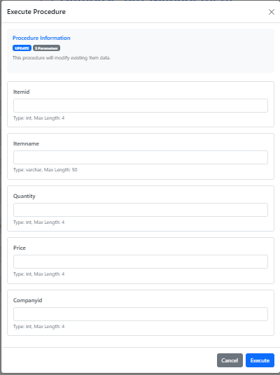

Without any additional item uptades, the item table of the company appears in the figures below;

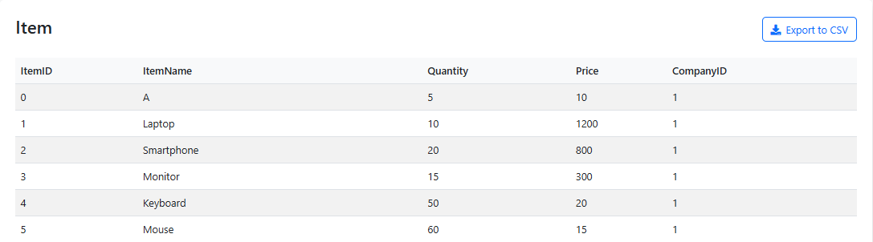

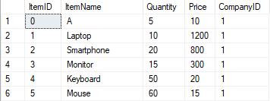

If we update the ItemName of the customer with ItemID number 0 to AAAA, the new display in the database will be as follows;

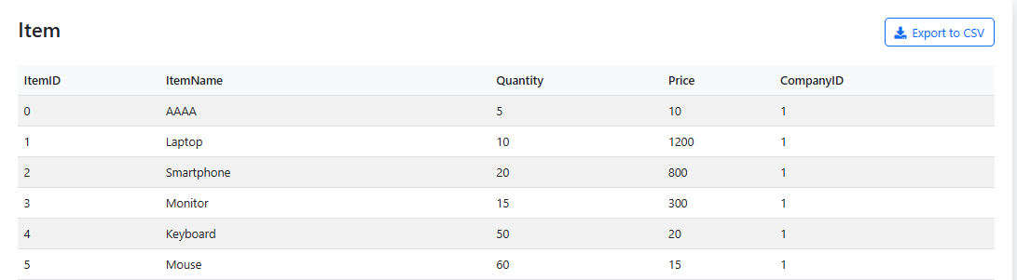

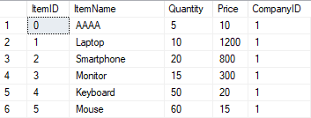

* + 1. **UpdateService**

In UpdateService procedure, we ask the service 16 parameters(Serviceid, Name, Startdate, Enddate, Price, Status, City, State, Country, Cloud, Security, Repair, Network, Softwaredev, Companyid, Departmentno) and update information a service to the company database.. The web interface image is as follows;

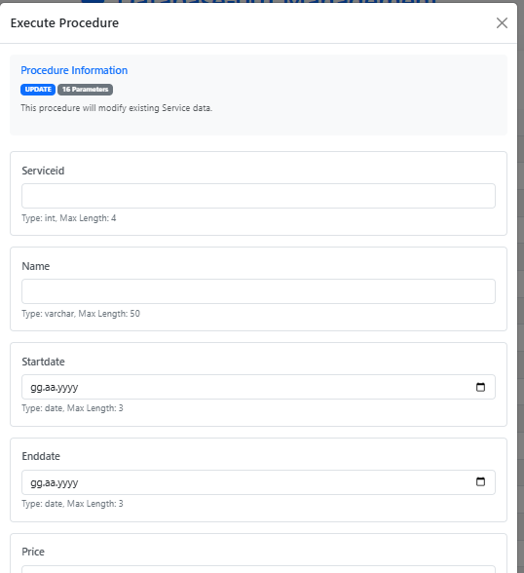

Without any additional service uptades, the service table of the company appears in the figures below;

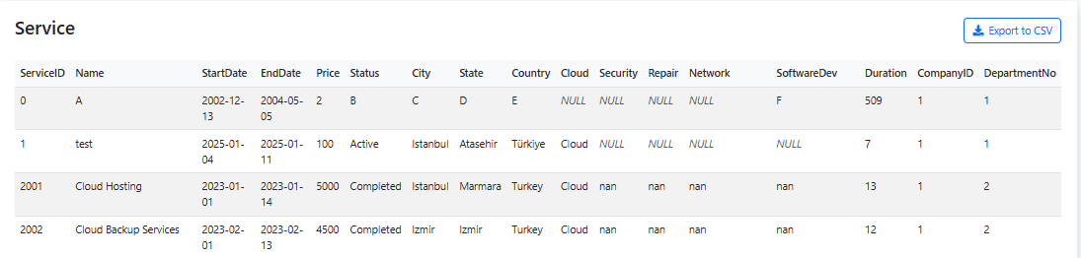



If we update the ServiceName of the service with ServiceID number 0 to AAAA, the new display in the database will be as follows;

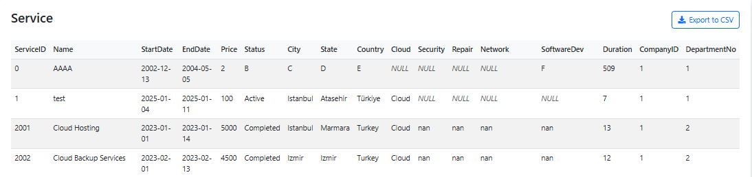



**2.4 Delete Procedures**

These procedures are used to delete data from the company database.

**2.4.1 DeleteCompany**

In DeleteCompany procedure, we ask the company just 1 parameters(Companyid) and delete the company. The web interface image is as follows;

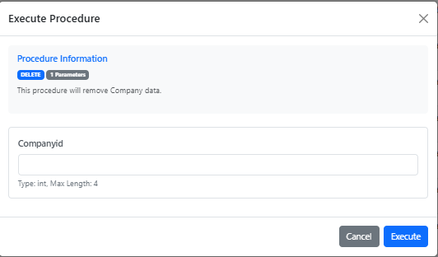

Before deletion, the company class looks like this;

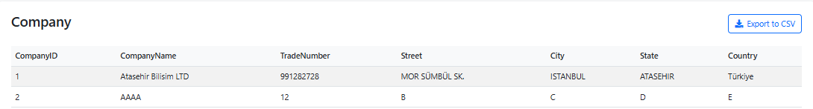

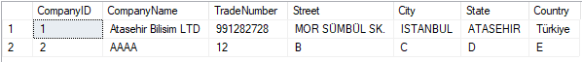

When you delete the company with companyID equal 2, the tables appear as follows;

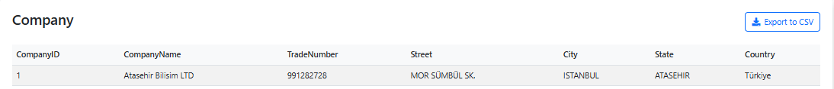



**2.4.2 DeleteCustomer**

In DeleteCustomer procedure, we ask the customer just 1 parameters(Customerid) and delete the customer. The web interface image is as follows;

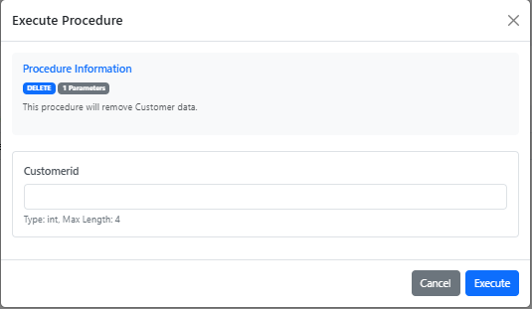

Before deletion, the customer class looks like this;

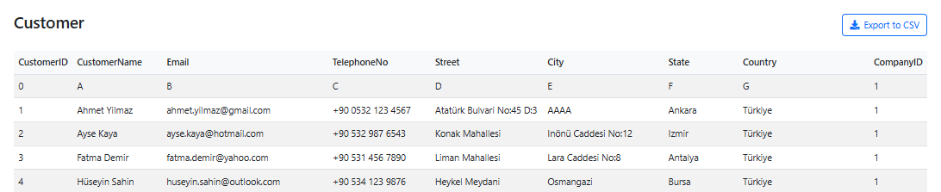

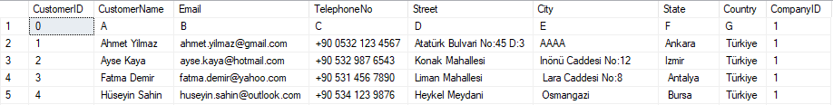

When you delete the customer with customerID equal 0, the tables appear as follows;

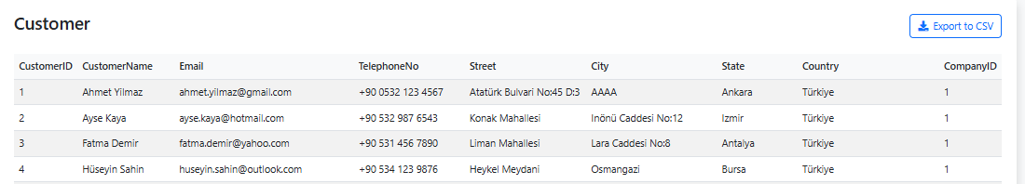

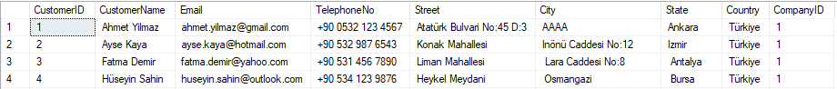

**2.4.3 DeleteDepartment**

In DeleteDepartment procedure, we ask the department just 1 parameters(Departmentid) and delete the department. The web interface image is as follows;

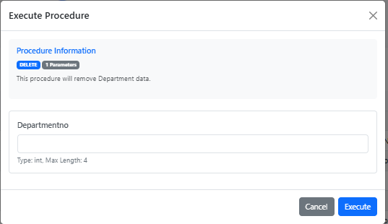

Before deletion, the department class looks like this;

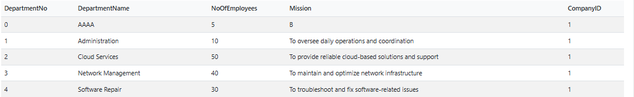

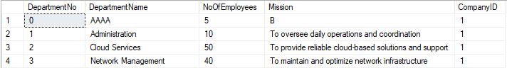

When you delete the department with DepartmentNo equal 0, the tables appear as follows;

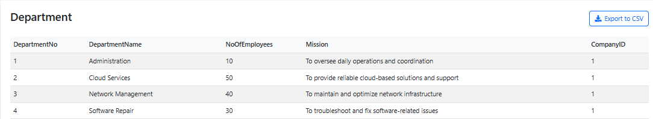

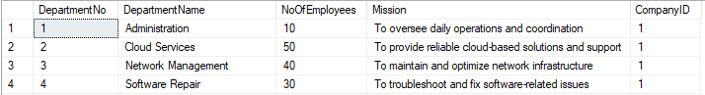

**2.4.4 DeleteItem**

In DeleteItem procedure, we ask the item just 1 parameters(Itemtid) and delete the item. The web interface image is as follows;

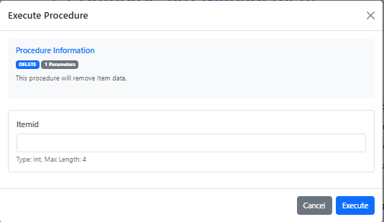

Before deletion, the item class looks like this;

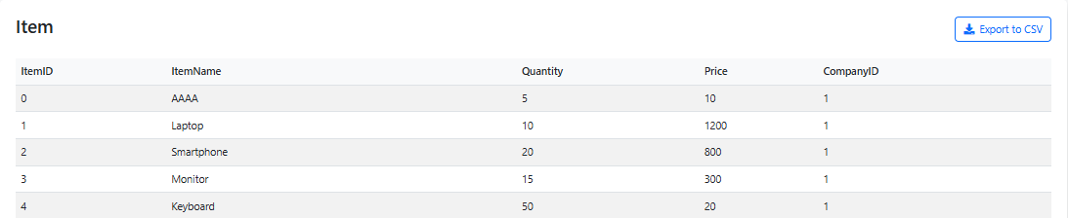

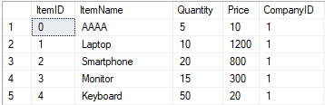

When you delete the item with ItemNo equal 0, the tables appear as follows;

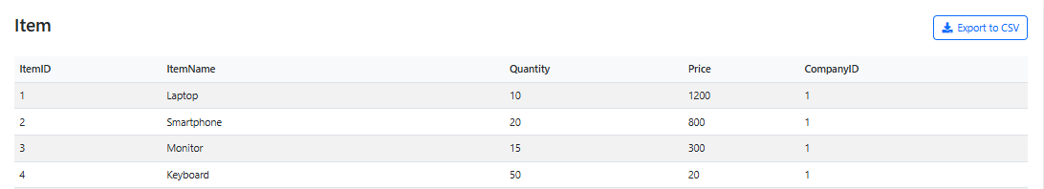

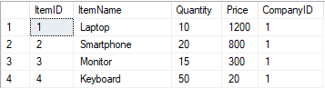

**2.4.5 DeleteService**

In DeleteService procedure, we ask the service just 1 parameters(Servicerid) and delete the service. The web interface image is as follows;

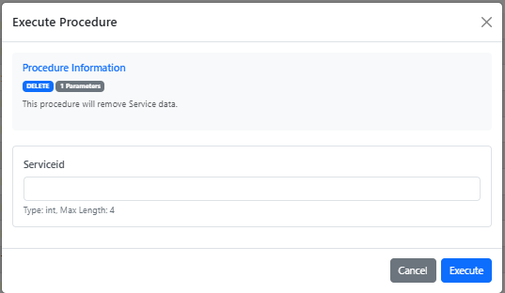

Before deletion, the service class looks like this;

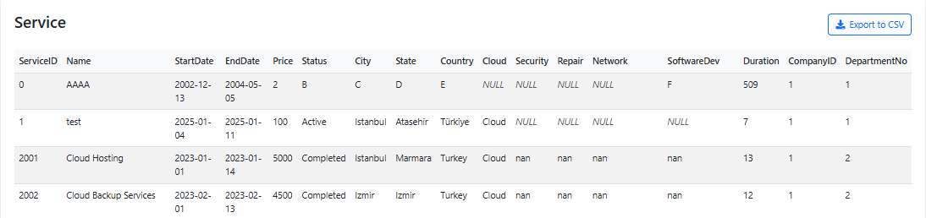



When you delete the service with ServiceID equal 0, the tables appear as follows;

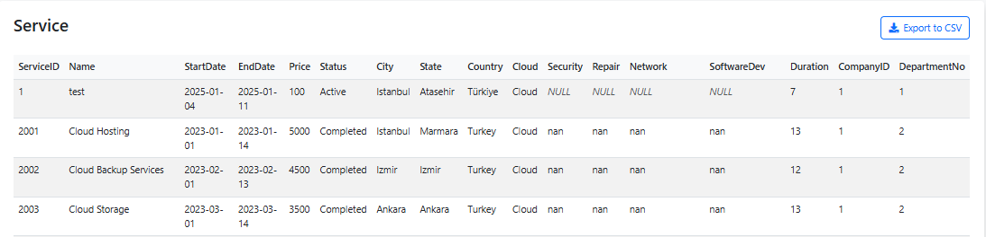



* 1. **Wievs**

In the wiew part you can access the total, average, maximum and minimum values of data such as company, employees, items, service status. Below are images of overviews by input type;

* + 1. **CompanyOverwiev**

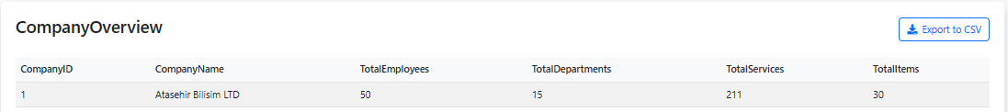

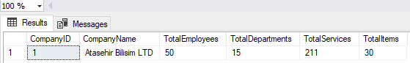

* + 1. **DepartmentEmployeeOverwiev**

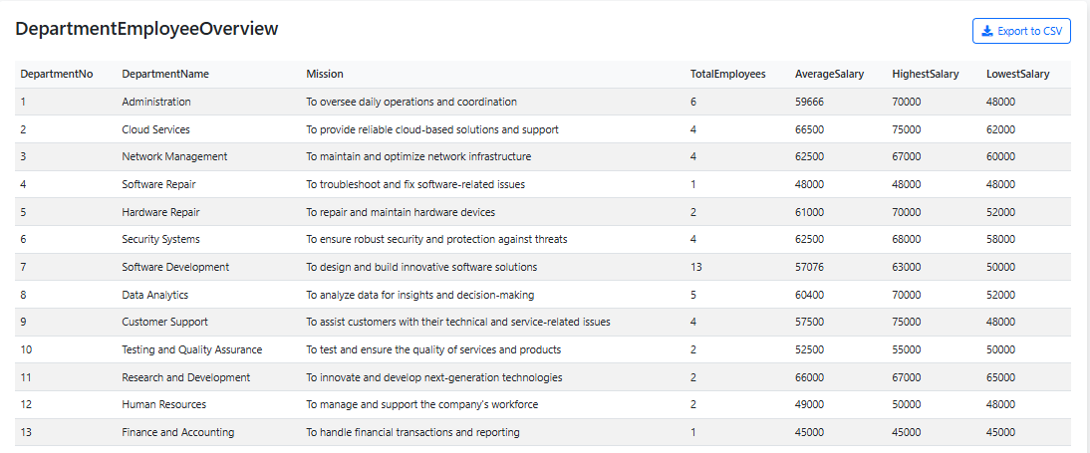

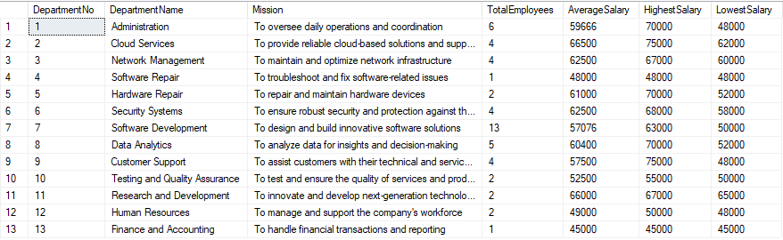

* + 1. **DepartmentItemOverwiev**

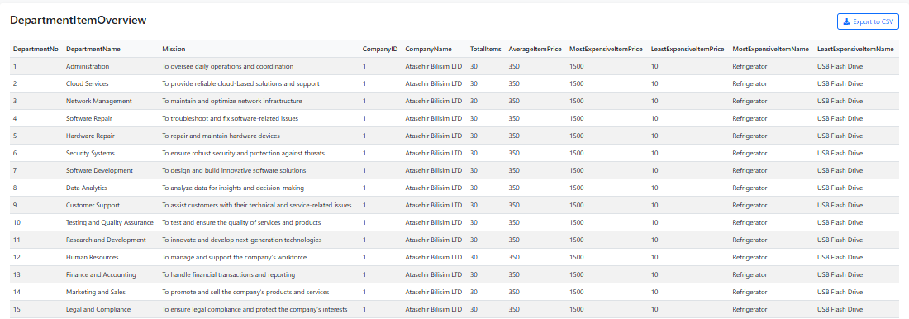

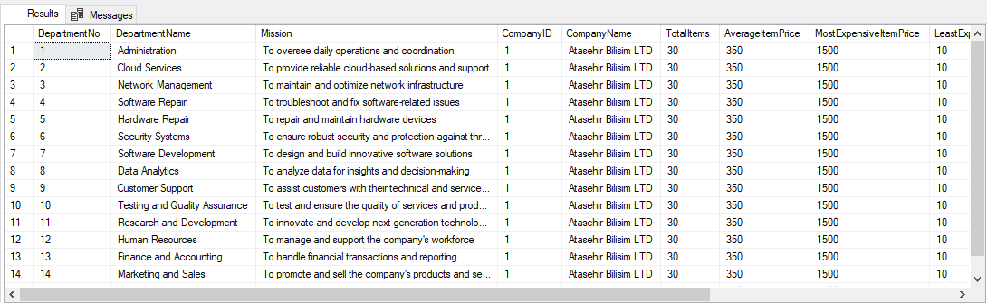

* + 1. **ServiceStatusOverwiev**



